**VERIFICATION OF DYNAMIC**

**CHARACTERISTICS OF AN EPICYCLIC GEAR TRAIN**

**USING EPICYCLIC GEAR TRAIN APPARATUS**

Name: Mubasshir Akhtar

Roll no.:21ME01058

**Aim of the experiment:**

To calculate angular velocity ratios experimentally and match the theoretical angular velocity ratios and find the errors.

**Apparatus required:**

* Epicyclic gear train experimental setup.

**Theory:**

A gear train is a mechanism with two or more gears meshed in series and its axes interlocked by a proper link to transmit power and to increase or decrease rotary speed. The combination of gear wheels used to increase or decrease the speed of the driven shaft is known as the gear system. A gear train having a relative motion of axes is called an epicyclic or planetary gear. The epicyclic gear train is a two-degrees-of-freedom device that is used to transmit motion as its degree of

freedom is two hence two inputs are required in order to get a desirably controlled motion of output but this is not the same for all the cases because in some other cases one input is provided and results two fictionally coupled outputs.

In the epicyclic train, the axis of one of the gears also moves relative to the frame as an epicyclic gear train consists of more than two gears mounted so that the centre of one gear revolves around the centre of the other with relative motions of axes. Epicyclic gearing arrangement consists of four different elements that produce a wide range of speed ratios. These elements are (1) Sun gear which is an externally toothed ring gear co-axial with gear train; (2) Annular gear, an internally toothed ring gear co-axial with gear train; (3) Planetary gear, an externally toothed gear that meshes with the sun and annular gear; (4) Planet carrier, a support structure for the planet gears, co-axial with the gear train. The planet and sun gears mesh to roll their pitch circles without slipping.

Epicyclic gear is of two types and they are simple and compound gears. The simple type of setup has one sun, one ring, one carrier, and one planet set when it comes to compound type it is mainly divided into a meshed planet, steeped planet, and multi-stage structure.

1. **Meshed planet:**

There are at least two more planets in mesh with each other in each planet train.

1. **Steeped planet:**

A shaft connection exists between two planets in each planet train.

1. **Multistage structure:**

The system contains two or more planet sets.

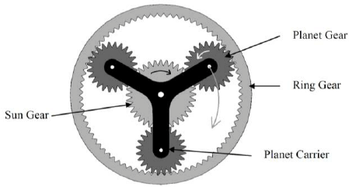

Fig.1: Planetary gear arrangement

Compound Epicyclic gear train gives large reduction ratio, higher torque-to-weight ratio and more flexibility than the simple epicyclic one. There exists a relative motion between axis of gears in mesh. Central (sun gear) is ‘s’, planet gear named as ‘p’ and outer ring gear as ‘I’. Arm or carrier connects the gear axes. The number of teeth of the sun(ts), planet(tp) and ring gears (ti) are 34, 18 and 70 respectively.

The module of the gear ‘m’ is given by:

$$m=\frac{d}{t}$$

where ‘d’ is the pitch circle diameter of the gear and ‘t’ is the number of teeth of the gear. The angular velocity ratio ‘mv’ is given by+

$$m=\frac{w_{out}}{w_{in}}=±\frac{d_{in}}{d_{out}}=±\frac{t_{in}}{t_{out}}$$

where ‘+’ sign for internal meshing and ‘-’ for external meshing.

Now, for the given compound gear train meshing the angular velocity ratio (mV) can be expressed as:

$$m_{v}=\frac{N_{F}}{N_{D}}=-\left(\frac{t_{D}}{t_{A}}\right)×\left(\frac{t_{B}}{t_{F}}\right)$$

$$=\frac{product of teeth of drivers}{product of teeth of followers}$$

**Driving gear ratio:**

|  |  |  |  |  |  |
| --- | --- | --- | --- | --- | --- |
| **S No.** | **Operation** | **Carrier Arm(C)** | **Sun Gear**  **(S)** | **Planet Gear**  **(P)** | **Ring Gear**  **(I)** |
| 1. | C is fixed  S+1 Rev. | 0 | Ns=+1 | $$N_{p}=-\frac{t_{s}}{t_{p}}×N_{s}$$ | $$-\frac{t_{s}}{t_{p}}×\frac{t_{p}}{t_{i}}=-\frac{t_{s}}{t_{i}}$$ |
| 2. | C is fixed  S+x Rev. | y | Ns=x | $$N_{p}=-x×\left(\frac{t_{s}}{t_{p}}\right)$$ | $$x×\left(-\frac{t_{s}}{t_{i}}\right)$$ |
| 3. | Add y | y | Ns=x+y | $$N_{p}=-x×\left(\frac{t_{s}}{t_{p}}\right)+y$$ | $$x×\left(-\frac{t_{s}}{t_{i}}\right)+y$$ |

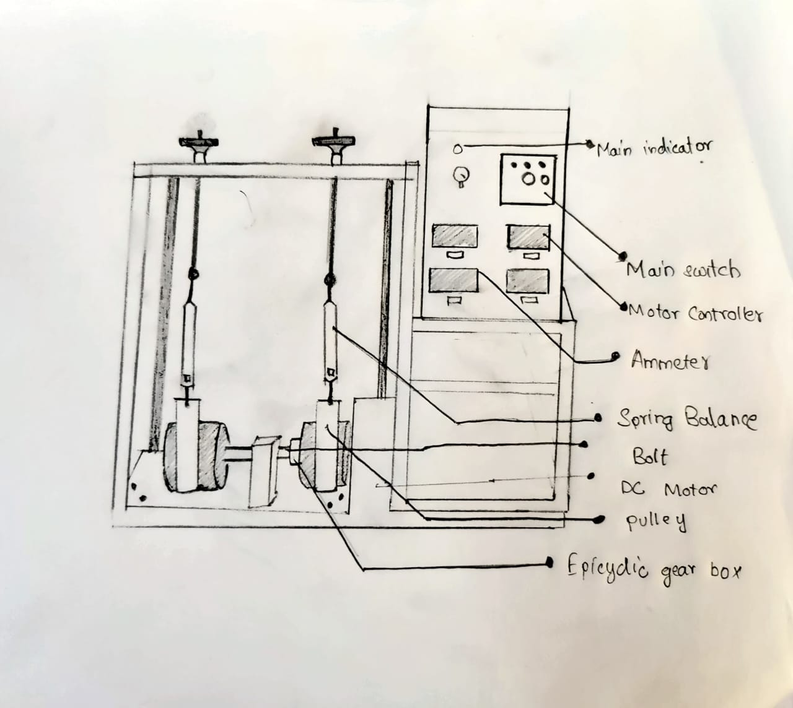

Fig. 2: Epicyclic gear train apparatus

**Condition 1:**

The carrier arm (C) is locked and 1 revolution is given to Sun gear (S). Therefore, the angular velocity ratio

$$\frac{N_{s}}{N_{i}}=\frac{w_{s}}{w_{i}}=\frac{x}{-x×\left(\frac{t_{s}}{t_{i}}\right)}=-\frac{t_{i}}{t_{s}}=-\frac{70}{34}=-2.058$$

So, the ring moves 1 revolution for 2.06 revolutions of sun gear and both move in opposite direction.

**Condition 2:**

Ring gear is locked and 1 revolution is given to carrier arm(C).

$$y=1 and -x×\left(\frac{t_{s}}{t_{i}}\right)+y=0$$

$$x=\left(\frac{t_{s}}{t_{i}}\right)=\frac{70}{34}=2.058$$

Carrier arm(C) makes y revolutions for x+y revolutions of sun gear. Now angular velocity ratio

$$\frac{N_{s}}{N_{c}}=\frac{x+y}{x}=1+2.058=3.058$$

Therefore, the carrier arm(C) makes 1 revolution for 3.058 revolutions of sun gear and both move in same direction

**Advantages:**

The planetary gearbox offers a set of distinct advantages which makes it an interesting alternative to traditional gear types such as helical and parallel shaft gearboxes in applications requiring:

* High reduction ratios.
* Compact and lightweight with high torque transmission.
* High radial loads on the output shaft.
* It is quieter in operation.
* Uniform distribution of load over all gears having greater tooth contact.
* All gears are constantly in mesh, so a change of one gear to another is possible without any loss.

**Disadvantages:**

* Assembly of gears is limited to specific teeth per gear ratios.
* This system is complex and difficult to repair if damaged.
* Driver and driven equipment must be in line to avoid additional gearing.

**Procedure:**

1. First let the carrier arm and Internal gear be free. So that we start giving rotational motion to Sun gear to get 2 degrees of freedom.
2. Note the values of the speed in this case.
3. Then, for the second case, fix the carrier arm. Start giving the angular velocity to the Sun gear.
4. In the same way increase the speed of the Sun gear and take the reading of the Sun gear speed, Internal gear speed at five different instances.
5. Then, for the third case, fix the Internal gear.
6. Start giving the angular velocity to the Sun gear.
7. Take the reading of Sun gear speed and Carrier arm speed at five different instances.
8. Then find the angular velocity ratios for each case and compare them with the theoretical values and calculate the error.

**Sources of error:**

* The experiment is done and the results were compared to experimental data.
* Errors between analytical and experimental methods are due to mechanical and frictional losses that occur during the execution of the experiment.

**Precautions:**

* Do not increase the current supply over 2.2A as the setup will start vibrating, leading to inaccurate results.
* Take care while tightening the rope on the gear so that they don’t cause discrepancies in results.
* Ensure the power supply is properly insulated. Keep body parts and all objects away from the moving parts in the system.

**Conclusion:**

From this experiment, we were familiarised with the epicyclic gear train mechanism. We also calculated the gear angular velocity of gears by keeping the arm fixed and by keeping the ring gear fixed. We then added them to get total angular velocity. We then compared these values to the theoretically obtained values and found out the error.

Epicylic gear trains are used in watches, differential in cars and other machinery.

**References:**

* Image obtained from <https://www.researchgate.net/figure/Basic-layout-of-planetary-gearbox-5_fig1_260290993>
* https://www.jetir.org/papers/JETIR2004306.pdf